CDP Data Developer (3001) Certification Guide  
 ( by AMRIT CHHETRI, RCS()

**CREATED FOR : CDP-3001 Certification Training from Rosefinch,Siliguri**

Contents

CDP Data Developer Exam (CDP 3001) Details: 2

CDP Private Cloud Installation: 3

CDP Developer Workstation for CDP 3001 Certification: 7

Topics of CDP Data Developer Exam (CDP 3001) 8

Studying CDP 3001 Certification: 8

Self-Study Modules/Resources 9

CDP Coding Spark: 10

# CDP Data Developer Exam (CDP 3001) Details:

CDP Data Developer is latest Developer Certification from Cloudera and short details are:

1. Exam Number: CDP-3001
2. Number of questions: 65
3. Duration: 90 minutes
4. Pass Score: unpublished

We do not publish exam pass scores. Candidates should not be trying to achieve any particular score. Rather they should be aiming for the highest score possible.

1. Delivery: online, proctored
2. Please review the [system requirements](https://support.questionmark.com/content/participant-support-site) to enable online, proctored testing through QuestionMark
3. Allowed resources: none.
4. Official URL: <https://www.cloudera.com/about/training/certification/cdp-datadev-exam-cdp-3001.html>
5. Exam Portal(Purchase and Registration): https://support.questionmark.com/user/register
6. FREE Voucher: https://www.cloudera.com/about/training.html

# Training Steps:

These are recommended steps for the preparation of Cloudera Developer CDP-3001 Certification:

1. Register Account : https://sso.cloudera.com/register.html
2. Purchase Exam -directly or from Training Center: https://education.cloudera.com/store/2737716-cdp-3001-cdp-data-developer-exam

# CDP Private Cloud Installation:

1. **CDP Cluster Installations- for CDP Cluster:**The requirements for the installations of ***CDP Private Cloud Base(Cluster)*** are given below and they are based on [**https://supportmatrix.cloudera.com/**](https://supportmatrix.cloudera.com/) **.** There is requirement of 2 Virtual Instances each with 16 GB RAM and 250 GB HDD CDP Private Cloud Base (Cluster) installation.  
     **A. Requirements Details –with Ubuntu 20.04 LTS:**
   1. System Matrices:

|  |  |  |  |
| --- | --- | --- | --- |
| **Peripherals/Infrastructure** | **Peripherals/Infrastructure** | **Specifications** | **URL/Remarks** |
| Operating System | Ubuntu | 20.04 LTS | https://www.releases.ubuntu.com/20.04/ |
| RAM | 16 GB |  |  |
| Storage/HDD | 250 GB |  |  |
| CPU | X86-64 Architecture |  |  |
| Network Bandwidth | 3-5 MBPS | Unlimited |  |
| SSH User |  |  | cdproot with root privileges |

* 1. Number of Instances : 1
  2. Access Type : Root
  3. Number of Days : Till Training completes

1. **Requirements Details –with Ubuntu 20.04 LTS:**
   1. System Matrices:

|  |  |  |  |
| --- | --- | --- | --- |
| **Peripherals/Infrastructure** | **Peripherals/Infrastructure** | **Specifications** | **URL** |
| Operating System | Centos | 20.04 LTS | http://isoredirect.centos.org/centos/8-stream/isos/x86_64/ |
| RAM | 16 GB Tuned: 64 GB |  |  |
| Storage/HDD | 250 GB |  |  |
| CPU | X86-64 Architecture |  |  |
| Network Bandwidth | 3-5 MBPS | Unlimited |  |
| SSH User |  |  | cdproot with root privileges |

# 

***Cloudera Manager 7 Installation-Steps***

1. Register an account: https://sso.cloudera.com/onboarding.html?stepId=pocForm
2. Get installer for CDP Installer (60 Days Trial) https://www.cloudera.com/downloads/cdp-private-cloud-trial/cdp-private-cloud-base-trial.html
3. Check for supportable Linux OS(Ubuntu 20.04 or Centos) .Supporting OS : <https://supportmatrix.cloudera.com/>, and get Ubuntu 20.04, https://releases.ubuntu.com/20.04/ubuntu-20.04.4-desktop-amd64.iso
4. Request Trial at <https://www.cloudera.com/downloads/cdp-private-cloud-trial/cdp-private-cloud-base-trial.html>
5. Install Cloudera Manager with steps below( they are mentioned in the URL above too):
   1. Download Cloudera Manager Installer and install:
   2. $ wget <https://archive.cloudera.com/cm7/7.4.4/cloudera-manager-installer.bin>
   3. $ chmod u+x cloudera-manager-installer.bin
   4. $ sudo ./cloudera-manager-installer.bin
6. Once installer completes, create SSH user( cdproot) with Root/Admin Privileges

Option-1:  
 sudo adduser cdproot

sudo usermod -aG sudo cd root

Option-2:

sudo adduser cdproot sudo

Checks: groups cdproot

1. Install and start OpenSSH-Server to run at 22

# sudo apt-get install openssh-server

# sudo systemctl enable ssh

# sudo systemctl start ssh

1. SSH Login and Root Permission:
   1. SSH Login:

sudo nano /etc/ssh/sshd_config

or

sudo nano /etc/ssh/sshd_config

Add This : PermitRootLogin yes

* 1. Root User:

sudo gedit /etc/sudoer and allow NOPASSWRD logins

1. Start SCM Server sudo service cloudera-scm-server start  
   Other options:   
   sudo service cloudera-scm-server start

sudo service cloudera-scm-server stop

sudo service cloudera-scm-server restart

1. Access Cloudera Manager at https://<ip>:7180, username/password admin/admin/
2. Follow on-screen details to install and configure all parcels/packages
3. **Configure and verify Parcel URL Configuration before processing the installation**

(Works in most scenarios)...

***Cloudera Data Platform installation using Cloudera Manager 7:***

Now, follow the steps below to complete installation of CDP :

1. Login to Cloudera Manager 7 with given URL [http://54.255.20.131:7180](http://54.255.20.131:7180/) and credentials
2. Click on continue and define Cluster, Cluster-BS

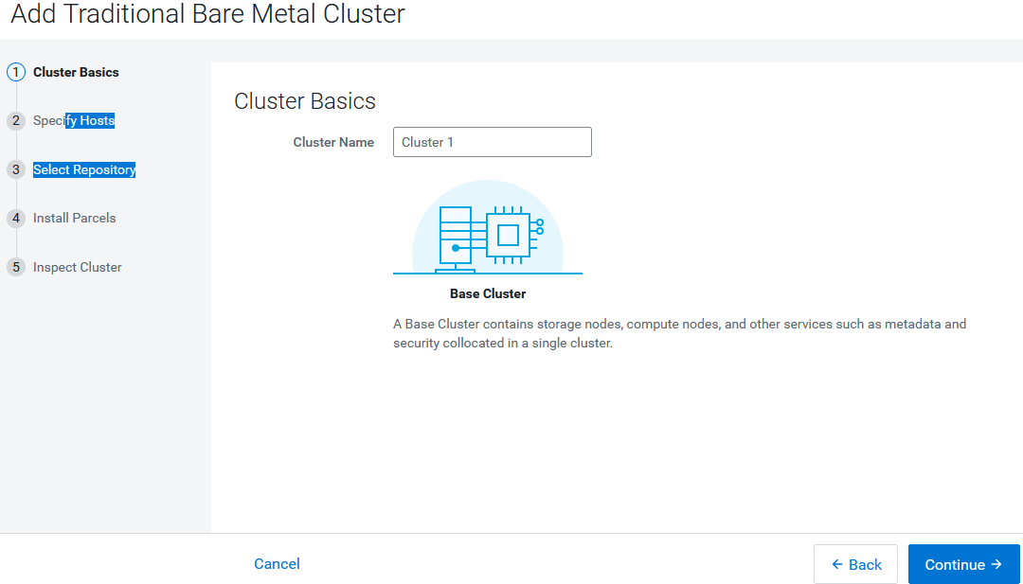

1. Click on continue and search the server system by Hostname

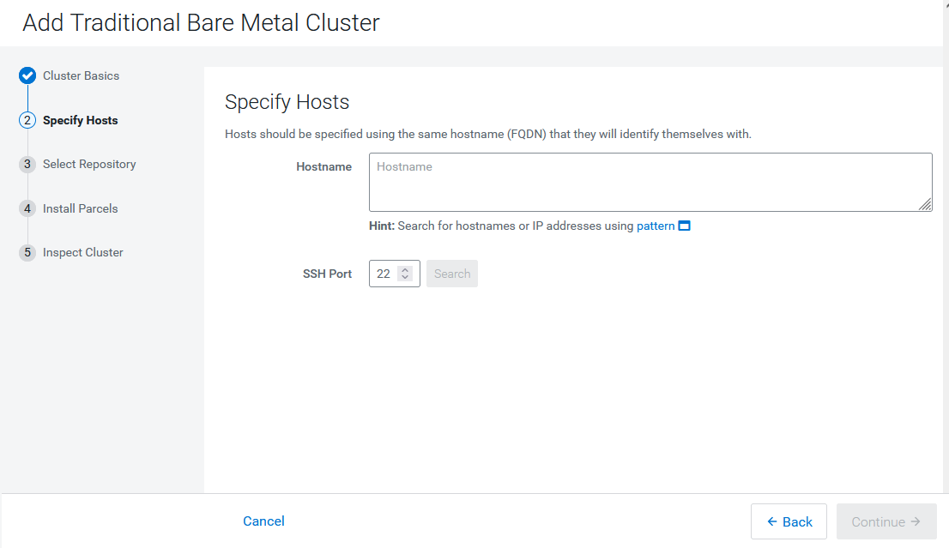

1. Before clicking Continue create another user with root permission/privileges

Option-1:  
 sudo adduser cdproot

sudo usermod -aG sudo cd root

Option-2:

sudo adduser cdproot sudo

Checks: groups cdproot

1. Permit RootLogin

sudo nano /etc/ssh/sshd_config

Add This : PermitRootLogin yes

sudo gedit /etc/sudoer and allow NOPASSWRD logins

1. Click next and select “System JDK” and continue, need start installing all packages.

**-------- Installed worked well in 2 VMs , have to update the contents here ....**

# CDP Developer Workstation for CDP 3001 Certification:

1. **CDP Data Developer Certification –for Participant’s Environment**
   1. System Matrices:

|  |  |  |  |
| --- | --- | --- | --- |
| **Peripherals/Infrastructure** | **Peripherals/Infrastructure** | **Specifications** | **URL** |
| Operating System | Windows 10 | Professional, 64-Bits | - |
| RAM | 4-12 GB |  | - |
| Storage/HDD | 80 GB | - | - |
| CPU | X86-64 Architecture |  | - |
| Network Bandwidth/Internet | 3-5 MBPS | Unlimited | - |
| Development SDK | Java | 11 | https://www.oracle.com/in/java/technologies/javase/jdk11-archive-downloads.html |
|  | Scala |  | https://www.scala-lang.org/download/ |
|  | Python | 3.10 | https://www.python.org/downloads/release/python-3100/ |
| Development IDE | PyCharm Edu (for Python) |  | https://www.jetbrains.com/edu-products/download/#section=pycharm-edu |
|  | IntelliJ Edu( Scala and Java) |  | https://www.jetbrains.com/edu-products/download/#section=idea-Scala |
|  | Jupyter Notebook |  | https://jupyter.org/install |
| Putty | Smart Putty | 3.0 | https://sysprogs.com/SmarTTY/ |
| Notebook | Notepad++ | 8.4.4 | https://notepad-plus-plus.org/ |
| MLOps Tools | Jenkins | 3.65 | https://www.jenkins.io/download/ |
|  | Jenkins X/GitOps |  | https://jenkins-x.io/ |
| Codes Management | Git | 2.37 | https://git-scm.com/downloads |
|  | Anaconda |  | https://www.anaconda.com/ |
|  |  |  |  |
|  |  |  |  |

* 1. Number Of Instance: 1 /Participant(Accessible Physically)

# Topics of CDP Data Developer Exam (CDP 3001)

<https://www.cloudera.com/about/training/certification/cdp-datadev-exam-cdp-3001.html>

**CDP 3001 Topics:**

1. Connect and move data between systems
2. Build and manage a data warehouse
3. Build, schedule, execute, and monitor data pipelines
4. Clean and serve data to the end-users
5. Perform data quality checks
6. Debug data issues reported by end-users
7. Data backup and disaster recovery

# Studying CDP 3001 Certification:

1. **Connect and move data between systems**
   1. Tools: Apache NiFi DataFlows,
   2. Moving: In and Out of Snowflake, Ozone using **NiFi**
   3. References:
      1. Moving Data: https://docs.cloudera.com/cfm/2.1.4/howto-exchanging-data.html
      2. Clouder Products : https://www.cloudera.com/products/pricing.html
2. **Build and manage a data warehouse**
   1. Tools:
   2. References
      1. DW Fundamentals : https://www.cloudera.com/about/events/webinars/modern-dw-fundamentals.html
      2. Designing of Enterprise Data Science Warehouse
      3. ***Designing( on AWS, Azure):*** <https://docs.cloudera.com/data-warehouse/cloud/index.html>

Handson on Dataware is must! CC free registration ….

1. **Build, schedule, execute, and monitor data pipelines:**
   1. Tools:
   2. References:
      1. Data Pipelines: <https://docs.cloudera.com/cdsw/1.9.2/jobs-pipelines/topics/cdsw-jobs-pipelines.html>
      2. Scheduling: <https://docs.cloudera.com/data-engineering/1.3.4/manage-jobs/topics/cde-schedule-job.html>
2. **Clean and serve data to the end-users**
   1. **References:**
      1. Cleaning Old Data: <https://docs.cloudera.com/runtime/7.2.6/troubleshooting-hue/topics/hue-cleanup-old-data-to-improve-performance.html>
3. **Perform data quality checks**
   1. References:
      1. Monitoring : <https://docs.cloudera.com/cdp-private-cloud-base/7.1.4/monitoring-and-diagnostics/cm-monitoring-and-diagnostics.pdf>
4. **Debug data issues reported by end-users**
   1. References:
      1. Debugging Issues with Models : <https://docs.cloudera.com/machine-learning/1.0/models/topics/ml-models-debug.html>
5. **Data backup and disaster recovery**
   1. References:
      1. HBase Backup Strategies: <https://docs.cloudera.com/cdp-private-cloud-base/7.1.3/hbase-backup-dr/topics/hbase-backup-dr-strategies.html>
      2. Backup Strategies: https://docs.cloudera.com/cdsw/1.9.2/cluster-management/topics/cdsw-bdr.html
      3. Backup : https://docs.cloudera.com/documentation/enterprise/6/6.3/topics/cm_bdr_howto_hdfs.html#backup_hdfs_from_prod_to_backup
6. **DevOps and Clouder Security**
   1. Tools: Git/GitHub, Jenkins, Anisible
   2. Jenkins in MLOps - [MLOps Guide | Jenkins X - Cloud Native CI/CD Built On Kubernetes (jenkins-x.io)](https://jenkins-x.io/v3/mlops/)
   3. Jenkin X for MlOps Pipelines - [Jenkins X - Cloud Native CI/CD Built On Kubernetes (jenkins-x.io)](https://jenkins-x.io/)
   4. References:
      1. Kafka Security : <https://developer.confluent.io/learn-kafka/security/intro/>

# Self-Study Modules/Resources

**Self-Study Modules/Resources- By Cloudera:**Related Training – Student should complete themselves on Cloudera OnDemand Training Library

1. https://www.cloudera.com/about/training.html

**Self-Study Modules/Resources- By Instructor:**

1. **Kafka Security** : <https://developer.confluent.io/learn-kafka/security/intro/>

https://confluent.cloud/environments/env-57yrng/add-cluster

Everything news, others covers CCA 175 but CDP-3001 is completely new with MLops using Jenkin X, Cluster Management!!!

Books – No available

1. E-Books
   1. [Book: Cloudera Data Platform Fundamentals and Concepts (hadoopexam.com)](https://www.hadoopexam.com/Cloudera_Certification/Book_Cloudera_Data_Platform_Fundamental_concepts.html)
   2. CDP Private Cloud Base: [Cloudera Data Platform Private Cloud Base with IBM Spectrum Scale [Book] (oreilly.com)](https://www.oreilly.com/library/view/cloudera-data-platform/9780738459387/)

# CDP Coding Spark:

**Systems Requirements for the Participants:**

1. **CDP Access** or own installation ( if anyone can manage own)
2. Pycharm Edu and Python - Python Coding for **PySpark**
3. Intellij IDE Edu- Java and Scala Coding for ***Spark Coding with Scala***
4. Firefox and Chrome Browsers –
   1. CDP Data Developer: https://www.cloudera.com/about/training/certification/cdp-datadev-exam-cdp-3001.html
   2. FAQ: https://www.cloudera.com/about/training/certification/cdp-faqs.html
5. **Recommended Resources Access:**
   1. Supporting Cloudera Courses: [https://education.cloudera.com/store?utf8=%E2%9C%93&st=free&commit](https://education.cloudera.com/store?utf8=✓&st=free&commit)=
6. **Remote Access to CDP for PySpark Shell:**
   1. Create Linux Users on CDP Server , example CDP3001-001
   2. Getting remote session on Smart Putty, <https://sysprogs.com/SmarTTY/download/>
   3. Starting Spark shell , $ spark-shell or spark2-shell
   4. Checks with Sample Code:  
      Scala>val log = sc.textFile("/tmp/logs")  
      scala>print(log)

***Note: Practical Labs on Spark( Python) on Shell, Jupyter Notebook and PyCharm, Scala on Shell, Intellij and Jupyter Notebook and all necessary labs during the sessions, started making them!***

https://docs.cloudera.com/data-warehouse/1.1/managing-warehouses/topics/dw-private-cloud-create-database-on-ozone.html